**Q. Assignment 3  
  
Simulate the FCFS algorithm.  
  
Input: Take input from a text file.**

**Output: TAT, WT, RT, and RD for all the processes and compute their average.**

**Code>**

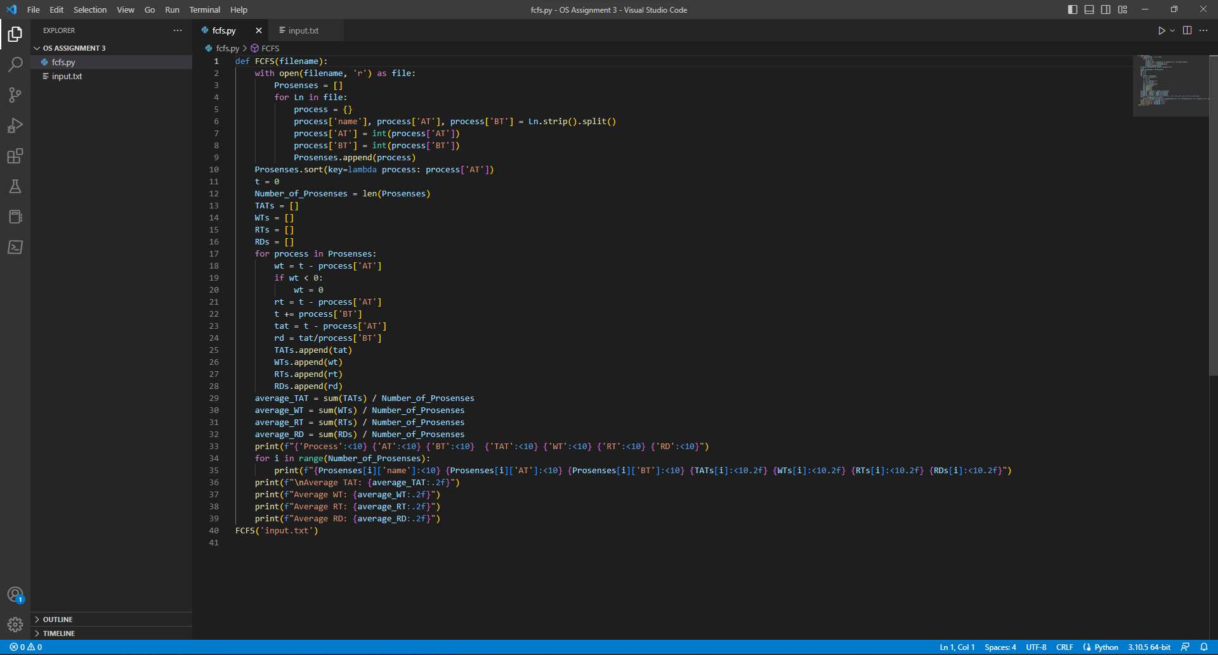

**Input>**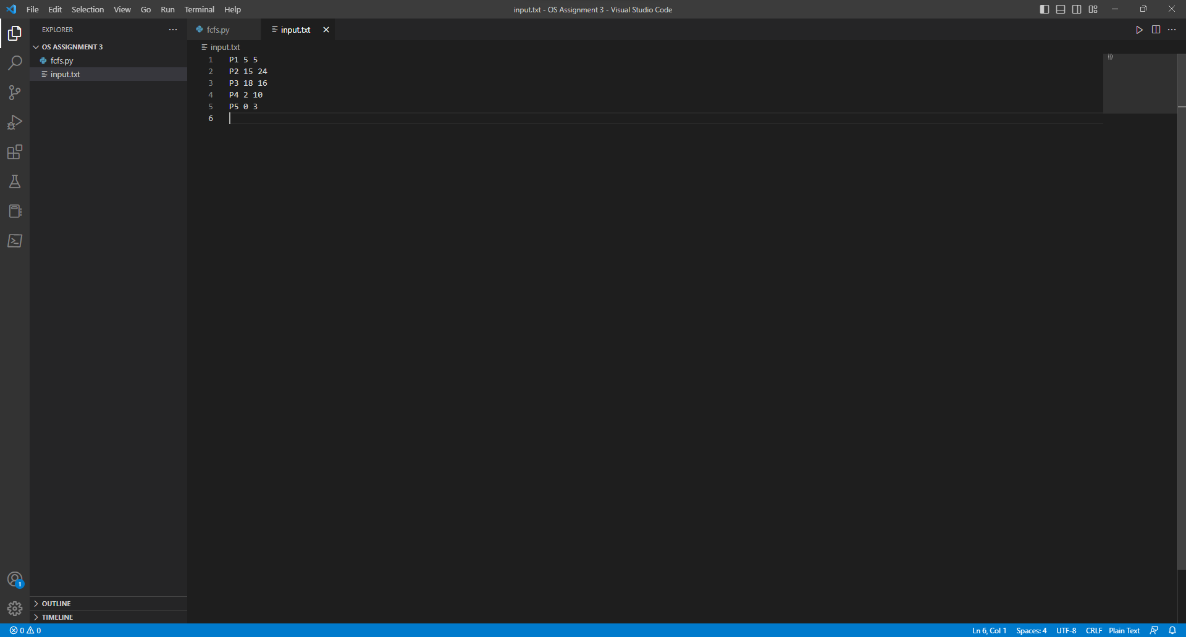

**Output>**

